All lay summaries should be written at a ninth grade reading level. This assures that all committee members are able to understand the information in the proposal. However, it can be difficult to remember exactly what constitutes a ninth grade reading level. The Flesch-Kinkaid reading level tool in Microsoft Word can be helpful in checking the readability of a document.
To check the reading level of your lay summary, type the summary into Microsoft Word. Then, from the menu, select Options and under the File tab and select Proofing. Be sure 'Show Readability Statistics' is checked.
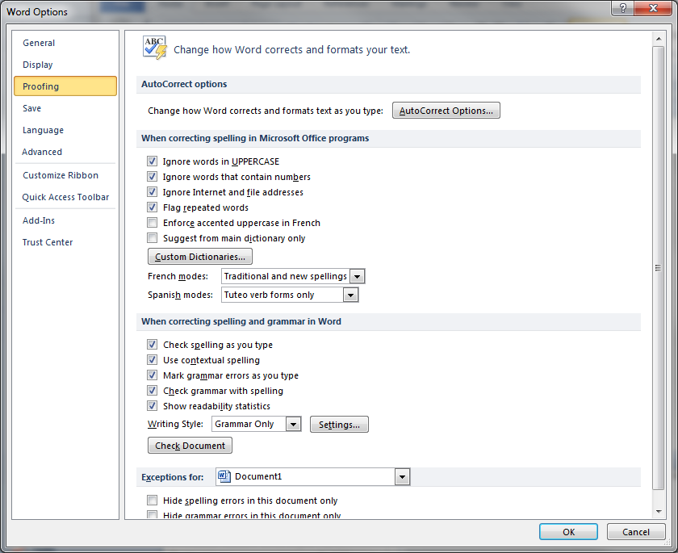

Click OK, return to your document, highlight the paragraphs you have typed, then select Tools/Grammar from the menu and run a grammar check on the information. When the grammar check has completed, you will see the readability statistics, including the Flesch-Kinkaid evaluation.

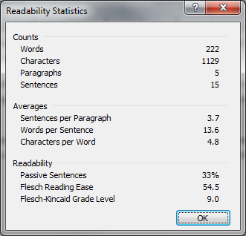

In general, a 9.0 would mean a 9th grade reading level for the summary.

